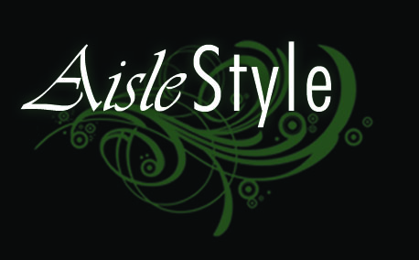
THE FOLLOWING TERMS AND CONDITIONS WILL BE ACCEPTED UPON RECEIPT OF DEPOSIT

Tentative Bookings:
Tentative bookings will only be held for a period of seven (7) days.

Booking Confirmations:
A 30% deposit must be paid to secure your booking. Once paid, this deposit is non refundable.

Final Payments:
The full balance of the account is due fourteen (14) days prior to the event date.

Booking Cancellations:
In the event of a booking cancellation, the deposit paid will not be refunded. If the cancellation occurs within the fourteen (14) days of the intended event date, no monies will be refunded.

Stock availability and Changes:
Aisle Style can only guarantee the availability of the items stated in your quote. Any further requirements are subject to further confirmation.
All requirements, including colours, setup arrangements and final numbers must be finalised at least three (3) weeks prior to the event date. Any increases in requirements at this stage cannot be guaranteed. Any reduction in items will not be refunded after this time.

Inclement Weather:
In the event of bad weather conditions that prevent the event taking place at the arranged site, no money will be refunded. Aisle Style will do their best to accommodate any reasonable requests to set up your ceremony in an alternate location. Reasonable notice must be given and Aisle style will not be held responsible for anything that does not go to plan.
In the event of heavy rain or wind, Aisle style has the right to refuse rolling out carpets or erecting Bali Flags and umbrellas if it is deemed detrimental to the condition of the items or the safety of the public.

Loss/Damages:
All items hired remain the property of Aisle Style and clients will be charged accordingly for any loss or damages to items. Excessively soiled carpets will incur a $100 cleaning fee.

Delivery and Surcharges:
All delivery and set up charges will be clearly stated on your quote. Public Holidays will incur a surcharge and will be clearly stated on your quote.

Permits:
It is the responsibility of the client to obtain relevant permits that may be required. Aisle Style can help advise you of what it required, but will not be held responsible for clients not adhering to permit regulations.

Site Cleanup:
Aisle Style cannot be held responsible for any rubbish left behind after the ceremony, unless Aisle Style was booked for a cleanup service. Aisle Style will not be responsible for any confetti particles left behind.

Advertising:
The client agrees to the possibility of photos being taken of their event for use on our website or in advertising.

Liability:
In no event shall Aisle Style and their respective affiliates, be liable for any injury, loss, claim, damage, exemplary punitive, incidental or consequential damages of any kind which arises out of or is in any way connected with the use of our services or equipment supplied by Aisle Style.

